Guided Capstone Project Report

The Big Mountain resort, a ski resort located in Montana, has recently installed an additional chair lift to help increase the distribution of visitors across the mountain. This additional chair increases their operating cost by $1,540,000 this season. How can Big Mountain Resort increase revenue by selecting a better value for ticket price to cover the additional operating cost by end of the season? After performing data wrangling, exploratory analysis, pre-processing and training over the provided data which contains information of 330 ski resorts in US, we build a model to predict ticket price.

Our modeling suggests $95.87 for weekend ticket price while The Big Mountain Ski Resort currently is charging $81 for weekend ticket. Even with the expected mean absolute error of $10.39, this suggests there is room for increase. The predicted ticket price is far above just covering the additional $1,540,000 operating cost, which can be compensated by raising the ticket price by 88 cents based on the expected number of visitors over the season is 350,000, on average, and visitors ski for 5 days. When modeling for predicting ticket price, we do find the number of fast quads, number of runs, snow making area, vertical drops, skiable Terrian area, and total chairs are important factors.

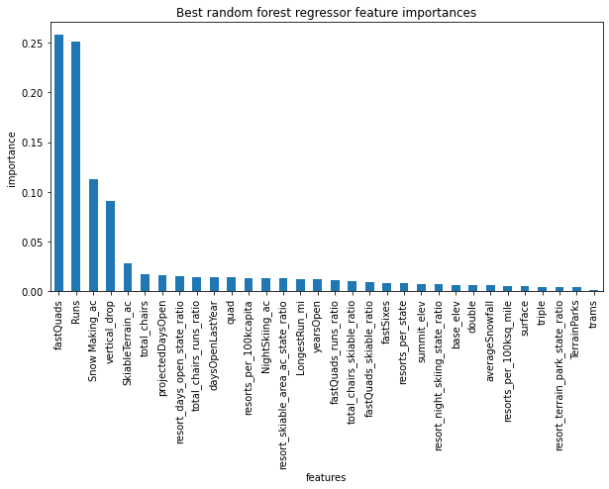

After running our model for several scenarios, the business comes up with, we recommend this scenario: increasing the vertical drop by adding a run to a point 150 feet lower down but requiring the installation of an additional chair lift to bring skiers back up, without additional snow making coverage.

This scenario supports $1.99 increase of ticket price, and the expected revenue will be increased by $3,474,638 over the season as a result.

We also recommend The Big Mountain Resort to find 5 least used runs, the number of visitors using those runs, and the operating cost for each of them, and compare the revenue loss and operating cost saving over closing 5 least runs and make the business decision for the run closures.

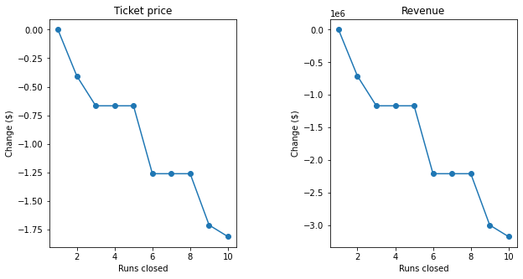

We will add a user-friendly interface for our model. Business analysts can run the model to test new combinations of parameters in a scenario to help senior management to make business decisions.